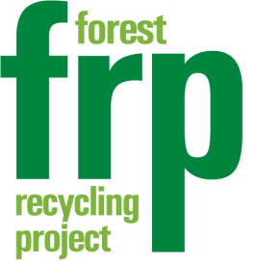
FRP Reclaimed Paint
Annual Membership Scheme

Save up to £500 compared to the cost of new paint
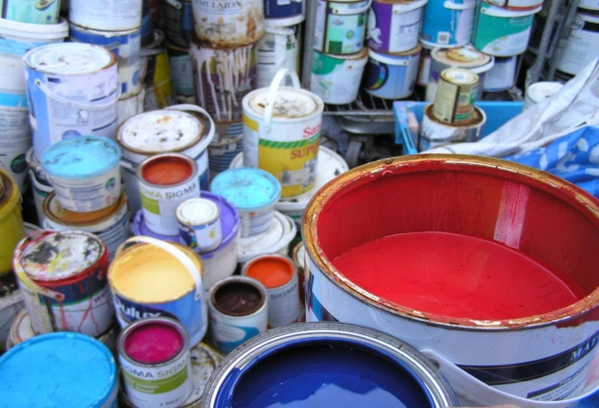
Community Centres and Halls
Youth and Scout Groups
Playgroups and Nurseries
Community Gardens and Allotments
Art Groups and Projects
Sports Groups and Meeting Rooms

Starting from £35

“The repaint scheme made it possible for us to paint a huge space, making it much brighter and more welcoming. Without the scheme the costs involved would have been prohibitive”
Waltham Forest Community Pool, Walthamstow
“Our Centre looks much brighter and cleaner and all our user groups are much happier as a result. It’s a great way for Charities to save money whilst helping the environment and we are delighted we signed up to the scheme”
The Docklands Settlement, Stratford

"Thank you to the Forest Recycling Project for their friendly and professional assistance and for taking the time to contact us when they heard we were in need of help”
FRIEND Animal Sanctuary, Kent

Contact FRP on 020 8539 9076 (leave a message) or paint@frponline.org.uk to find out more about our membership scheme.

To join the FRP’s Annual Membership Scheme, please complete the following and return with payment to Nilesh Patel FRP, 2c Bakers Avenue, Walthamstow, E17 9AW. Cheques should be made payable to ‘Forest Recycling Project’.
Annual Membership Application Form

Organisation Name
Organisation Type e.g. charity, school
Contact Name

Job Title

Address
for correspondence
Borough |  | Post Code
Telephone
Email
Website

Our annual paint membership offers groups a chance to save money and reduce their carbon footprint at the same time. Please tick the appropriate box to show which option you require.

Option 1- £35 for up to 50 litres of reclaimed paint
Option 2 -£50 for up to 75 litres of reclaimed paint

Terms and Conditions of FRP Annual Membership for Reclaimed Paint
1) Annual Membership is only valid upon receipt of a completed form and payment.
2) Only reclaimed paint can be supplied as part of your paint allowance.
3) Excludes all Black Paint, White Gloss and Clear Varnish
4) Once your paint allowance is reached, additional paint will be charged at £1 / litre.
5) Paint is supplied for organisational use only and not for resale.
6) FRP may review the terms of your membership at any time.
7) All reclaimed paint has been donated to FRP and is second-hand.

Please sign and date below to show you accept to the above terms and conditions:
Print Name
Signed Date

