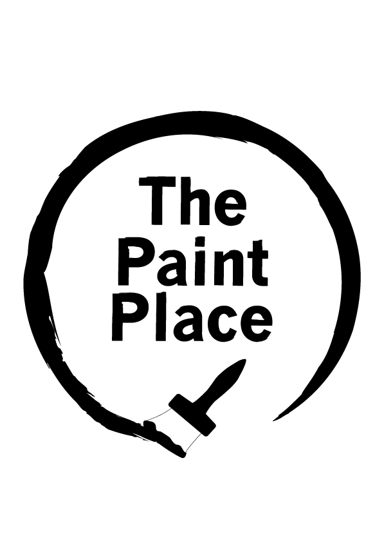
Which type of paint do I need?
The following is suggested guidance only. Please refer to manufacturer’s instructions on tin before applying paint.
Surface to be painted: | Suggested paint types:
INSIDE WALLS & CEILINGS  Lounge, Dining Rooms, Hallways, Bedrooms | EMULSION MATT or EMULSION SILK or WATER-BASED EGGSHELL or  WATER-BASED SATIN(WOOD)  Silk emulsion has a shinier finish than matt, so is easier to clean
INSIDE WALLS & CEILINGS  Kitchen, Bathroom, WC | KITCHEN & BATHROOM PAINT or WATER-BASED EGGSHELL or  WATER-BASED SATIN(WOOD)  K&B paint is moisture resistant and protects against condensation
INSIDE & OUTSIDE WOOD & METAL  Doors, Window Frames, Skirting Boards, Furniture | GLOSS Gloss paint has a shiny finish  SATIN(WOOD) Satin(wood) has a softer finish than gloss  EGGSHELL Eggshell has a duller matt finish than gloss & satin(wood)  Wood and Metal paint can be for interior or exterior use, refer to tin
INSIDE & OUTSIDE WOOD ONLY  Doors, Window Frames, Skirting Boards, Furniture | WOODSTAIN can be for interior or exterior use, refer to tin  VARNISH can be for interior or exterior use, refer to tin  TIMBERCARE for outside garden furniture and fences only
BARE WOOD & METAL (SURFACE PREPARTION)  Doors, Window Frames, Skirting Boards, Furniture | UNDERCOAT can be for interior or exterior use, refer to tin  PRIMER for wood or metal, interior or exterior use, refer to tin
EXTERIOR BRICKWORK AND MASONRY | MASONRY PAINT
OTHER SURFACES | FLOOR PAINT, TILE PAINT, PLASTER PRIMER
FRP The Paint Place, www.frponline.org.uk
How much paint will I need?
Dulux have an online paint calculator. Visit http://www.dulux.co.uk/calculator/ to help estimate the number of litres of paint you require for the surface and area to be painted.
The following table is suggested guidance only. Please refer to manufacturer’s instructions on tin before applying paint. Spreading rate and coverage will depend on how porous the surface to be painted is. More than one coat may be required.
One litre of emulsion paint for inside walls/ceilings will cover 13m2 (one coat)
2.5 litre tin emulsion matt/silk | will cover approx. 32m2
5 litre tin emulsion matt/silk | will cover approx. 64m2
10 litre tin emulsion matt/silk | will cover approx. 128m2
One litre of gloss paint for wood/metal will cover 12m2 to 16m2 (one coat)
750ml tin gloss paint | will cover approx. 9m2
2.5 litre tin gloss paint | will cover approx. 30m2
5 litre tin gloss paint | will cover approx. 60m2
One litre of exterior masonry paint for exterior brickwork will cover 15m2 (on coat)
5 litre tin masonry paint | will cover approx. 75m2
10 litre tin masonry paint | will cover approx. 150m2
FRP The Paint Place, www.frponline.org.uk

