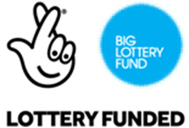
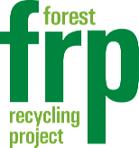
Reaching Communities
Application Form
Thank you for showing interest in our programme! We’re looking for volunteers resident in the borough of Waltham Forest and available for 1-3 days a week over a 1-3 month period.
*Required
Name *

Address & Postcode *

Email address *

(We will email about volunteering opportunities - you can unsubscribe anytime)

Phone Number*

Are you between 18 and 65 years old?* Yes No

What type of roles would interest you?

Please tick:
Recycling & Green Office | Outdoor activities (such as conservation or food growing) |  | Retail & Customer Service
Painting & Decorating | D.I.Y. & Carpentry |  | Food Preparation & Serving
Driving Delivery Van  If so, do you hold a license? |  | Other: (Please state)

How many days a week are you available? 1 day 2 days 3 days

Are you available for: 1 month Up to 2 months Up to 3 months

When would you be able to start:

How did you hear about the Forest Recycling Project?*

What do think you'd like to get from volunteering?

Is there anything we should know to support your volunteering better?
(This might be medical, or be about how you learn new tasks, or if you have episodes of ill health)

Contact name and number/s in case of any emergency*
(Name, home phone and mobile please)

Name
Home Phone
Mobile Phone

If relevant and you would like us to keep your support worker, case worker or referral agent informed about your volunteering please give their contact name and number/s.

Name, work phone/ mobile and email please - thanks!

